**Six Tuplets Game Jam – Game Design Document**

**1. Idea Outline and Gameplay Elements**

The game will take place on a desert island under threat from an incoming storm. The player must collect materials like wood and straw to construct a shelter before the storm hits.

- classic mario style platformer.

- stomp / avoid sea monsters

- gather collectibles (wooden planks, bushels of straw, ... )

- storm timer (countdown)

- target amounts for the resources

- player starts from build site

- play may only carry limited amount (1 piece)

- deliver material to build site, hut partially updates.

*"once the player picks up one part of the shelter, they then have to take it to the "safe zone", so in a way they have to go back and forth to give the idea they are building it in stages"*

*"it would make it more unique since it would change it up from an average platform style game. I also would hope with a time limit it would make it more fun as the player would have the stragadise how to get each piece in the right order before the timer ends"*

*"let the player start at the building site,  
and then she can go whatever direction she wants, explore the map, and hopefully find a wooden plank or somthing. and bring it back.  
and then - tadaa - a sound effect plays and the counter changes. "only 9 left to go"*

Win Condition:

- all necessary materials delivered to build site before timer hits zero.

Lose Condition:

- Timer hits zero, but not all materials gathered

Fake Screenshot (imagine 3d models though):

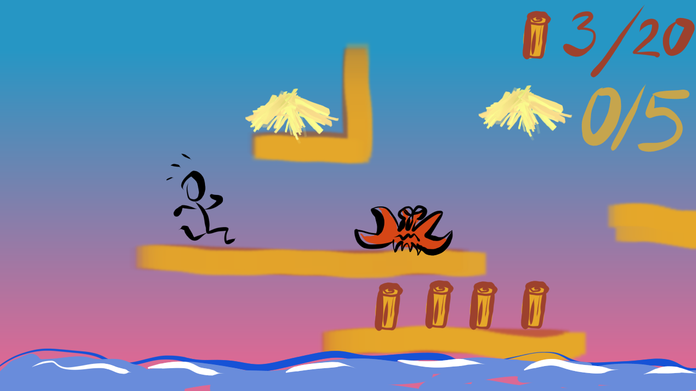

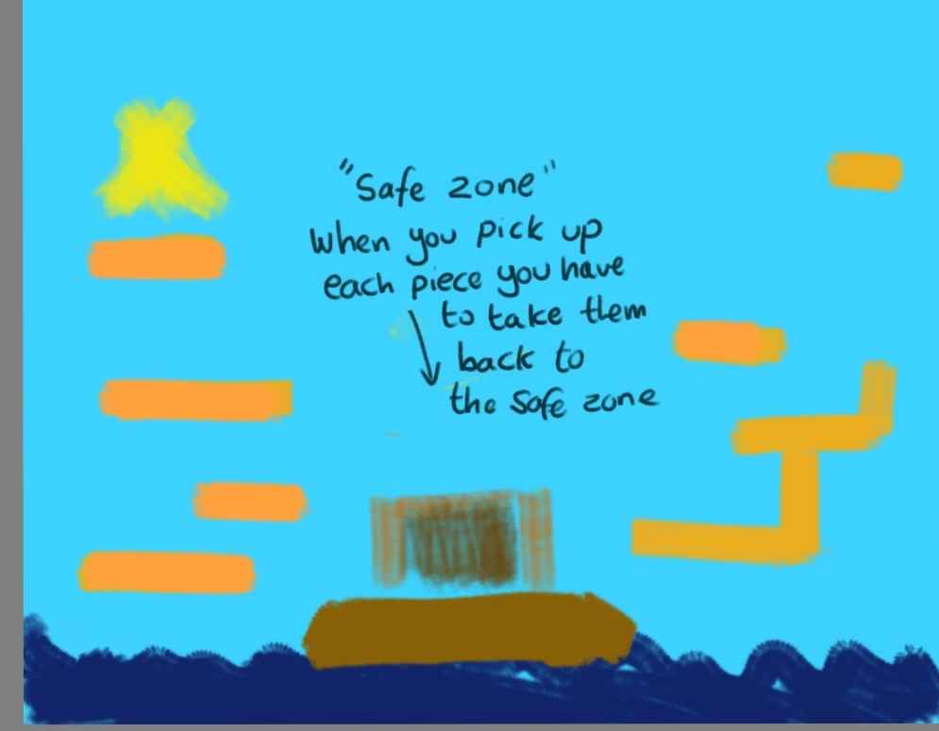

**Character Proportions:**

The models should be kind of small, like they could fit into a box, similar to mario or sonic.

That works better for platformers. Arokh tried realistic proportions for a platform character once, didn't work so well.

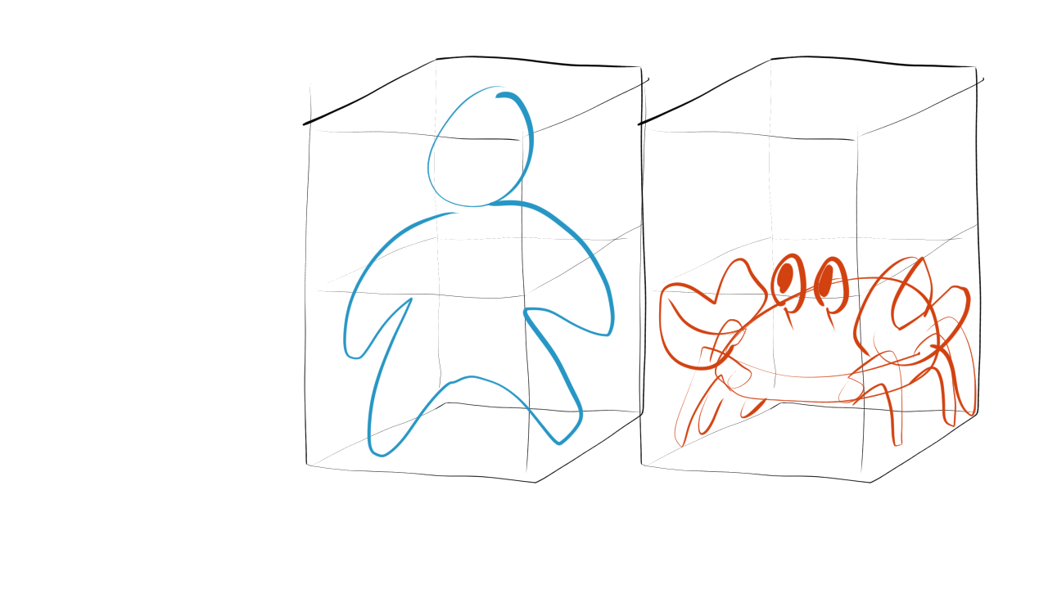

Environmental Feedback:

- the sun setting, the sky darkening, the thunder rumbling louder as timer nears zero

- (LOW PRIO / POLISH) : leaves and flowers (and the occasional piano) flying through the air as the wind picks up.

Collectible Materials:

- plank, straw bushel, sawed off tree trunk.

- size: one box

**2. The Art Style**

The Game will have a 3D art style in a 2.5D style game.

The assets will follow a cartoon/cel-shaded look.

Examples of similar art styles include Legend of Zelda Wind Waker.

(Subject to change due to artist's preferences)

The style will be low poly and a limited colour pallet.

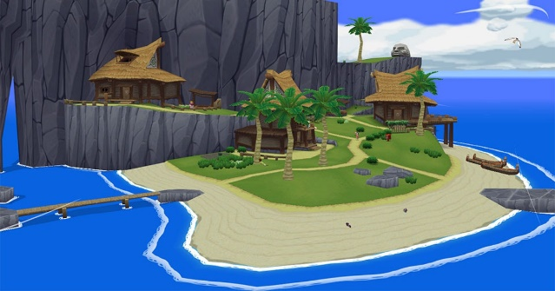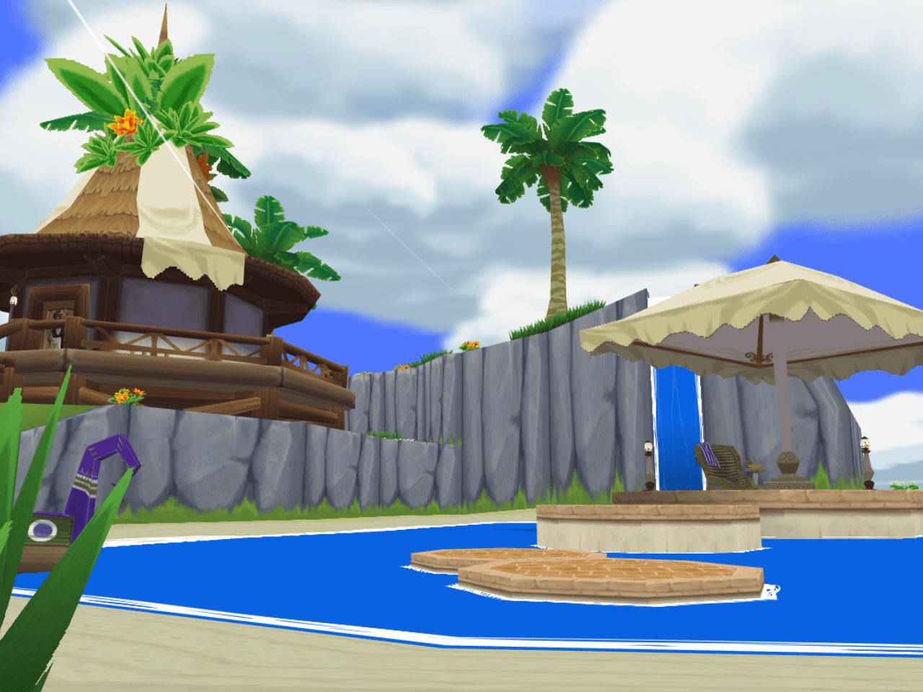

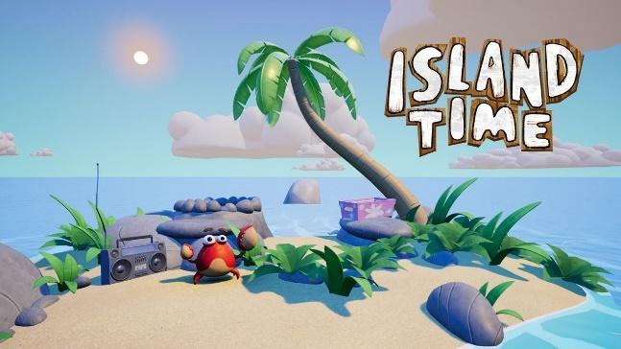

**Examples of what the game could be inspired to look like (e.g. Legend of Zelda Wind Waker)**

**2.1 Main Character Concepts:**

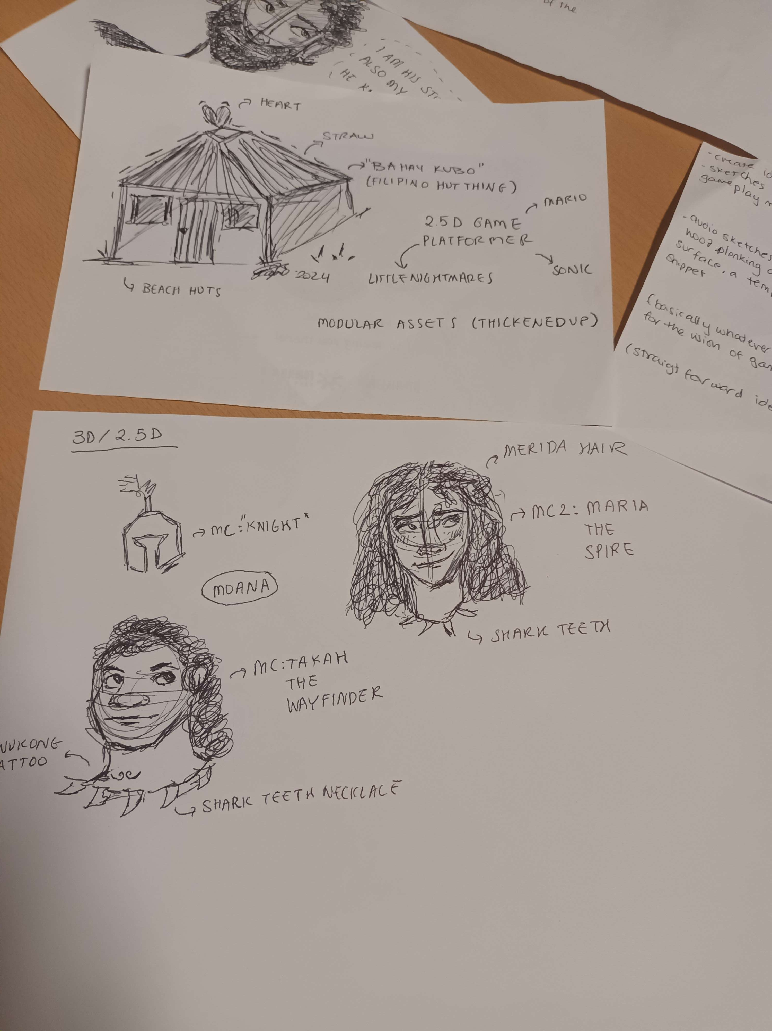

**2.2 Beach Hut / Shelter :**

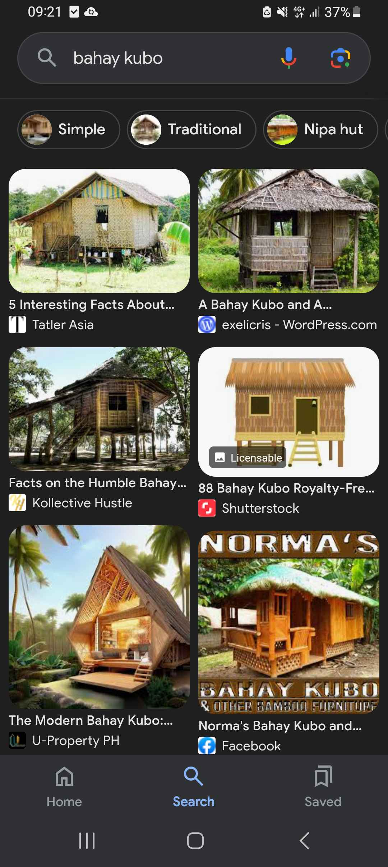

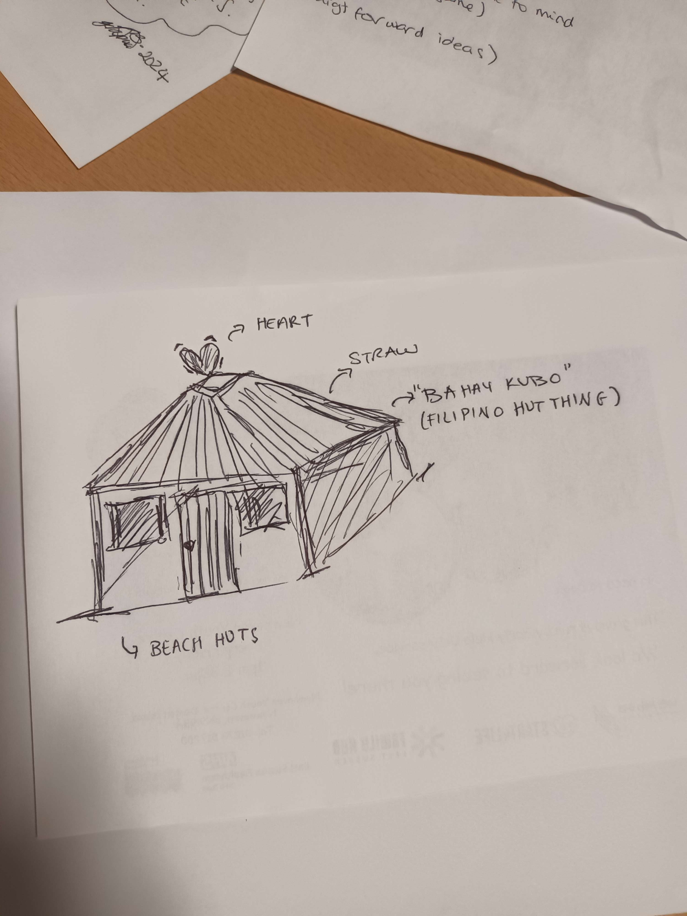

Monsters:

- monster doesn't have to be a crab.

- design up to what our art team fancies

Environment ( Terrain )

- build the level from basic block shapes in godot

- (doesn't have to be done by programmer, it's fairly simple in godot once you know the basic steps)

- if there's time, we can think about ideas to replace the blocks with prettier models

3. Sound Design

The Game will have a typically desert island soundtrack.

The music may start calm, before ramping up as the levels go on to build the pressure for the player. (subject to Audio lead’s preferences)

Natural sound effects such as birds and the ocean, as well as the sounds of wood/other materials for the falling objects.

3.1 Sound effects

- deliver material to build site

- pick up material

- player jump

- player run

- monster walk

- player hits monster (punt into sea)

- slam

- splash

- monster hits player: painful

- background ambience:  
 - timers in godot that will switch from one sound track to the next,   
 be it music or ambience, that gets more stormy over time.  
 - TODO: make godot change backround sounds with timers.   
 ideally with a nice, simple transition/cross fade.